Class Test
Chemical Effect of Electric Current
Total Marks: 20 Time: 35 mins
- Choose the correct option: (1×15=15)

- Which one of the following solutions will not conduct electricity?
- Lemon juice (b) Vinegar (c) Tap water (d) Vegetable oil

- Which of the following metals is used in electroplating to make objects appear shining?
- Iron (b) Copper (c) Chromium (d) Aluminium

- Which of the following solutions will not make the bulb in the Figure glow?
- Sodium chloride (c) Copper sulphate
- Silver nitrate (d)Sugar solution with distilled water
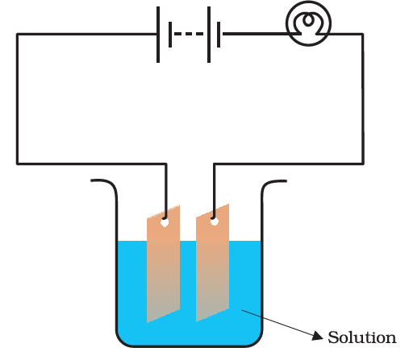

- In LEDs, the longer wire is always connected to _______ terminal
- Negative (b) Neutral (c) Positive (d) Any terminal

- When electrodes are immersed in water and electricity passed, the bubbles formed in positive terminal is a________ gas.
- Hydrogen (b) Oxygen (c) Carbon dioxide (c) None of them

- Adding a little dilute sulphuric acid with copper sulphate solution during electroplating is beneficial. Why?
- To increase acidity
- To increase conductivity
- So that the colour becomes more prominent
- To burn copper sulphate

- Tin cans used for storing foods are made by electroplating tin into iron. Why?
- Tin gives shiny appearance
- To make the vessel cheap
- Tin is less reactive than iron
- To make the vessel glitter

- Boojho and Paheli performed experiments taking similar bulbs and cells but two different solutions, A and B, as shown in the following figure.
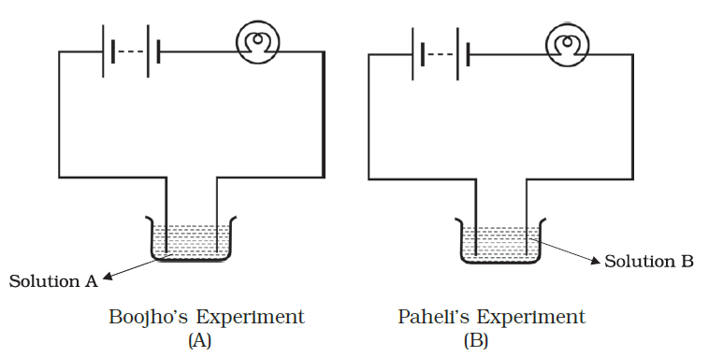
They found that the bulb in setup A glows more brightly as compared to that of setup B. You would conclude that
(a) higher current is flowing through the circuit in setup A.
(b) higher current is flowing through the circuit in setup B.
(c) equal current is flowing through both the circuits.
(d) the current flowing through the circuits in the two setups cannot be compared.

- Which of the following statement is correct?
- The object to be electroplated is taken as negative electrode.
- One of the most common applications of chemical effect of electric current is electroplating.
- Small amount of a mineral salt present naturally in water makes it a good conductor of electricity.
- All of the above.

- Boojho’s uncle has set up an electroplating factory near his village. He should dispose of the waste of the factory
- in the nearby river.
- in the nearby pond.
- in the nearby cornfield.
- according to the disposal guidelines of the local authority

- In a quiz competition, Payel was asked to choose the correct statement. Which of the following is correct?
- A strong electrolyte is a liquid or solution which conducts electricity very well.
- A weak electrolyte is a liquid or solution which conducts electricity to a lesser extent.
- A solid electrical conductor through which an electric current enters or leaves something like a dry cell, is called an electrode.
- All of the above.

- In the purification of an impure metal by using chemical effect of electric current, we should not take
- A thick rod of impure metal is made positive electrode.
- A thin strip of pure metal is made negative electrode.
- A distilled water salt of the metal to be purified is taken as electrolyte.
- A water-soluble salt of the metal to be purified is taken as electrolyte.

- Which of the following can be electroplated by chromium?
- Baketite and Graphite (c) Steel
- Graphite and steel (d) Graphite and Teflon

- Which of the following is incorrect?
- The process of depositing a thin layer of a desired metal over a metal object with the help of electric current is called electroplating.
- The chemical effect produced by an electric current depends on the nature of conducting solution and nature of electrodes.
- The fresh fruits and vegetables conduct electricity to some extent due to the presence of various salt solution in them.
- None of the above

- If + sign denotes the positive electrode and – sign denotes the negative electrode, which of the following is correct for an iron spoon to be copper plated?
- Iron spoon (+), copper plate (-), Iron sulphate electrolyte
- Copper plate (+), Iron spoon (-), Copper sulphate electrolyte
- Copper plate (-), Iron spoon (+), Copper sulphate electrolyte
- Iron spoon (-), copper plate (+), Iron sulphate electrolyte

- It is advisable to cut the electric supply before putting water over a fire caused due to electricity. Why? (2)

- Why do bubbles appear near the electrodes when an electric current is passed through a solution? (2)

- Assertion-Reasoning (1)
Assertion: When two free ends of a tester are dipped in lemon juice, the bulb in an electric circuit lights up showing that lemon juice conducts electricity.
Reason: All liquids conduct electricity.
- Both assertion and reason are correct and reason is the correct explanation of assertion.
- Both assertion and reason are correct but reason is not the correct explanation of assertion.
- Assertion is correct but reason is long.
- Assertion is wrong but reason is correct.

